Lab 7

Exercise#1: Design D flip-flops with Enable, Clear and Preset control lines as shown in Fig.3. Verify the designs with given truth table and in-blocks of flip-flop
Boolean Expressions | Logic Diagram
Bus using mux | 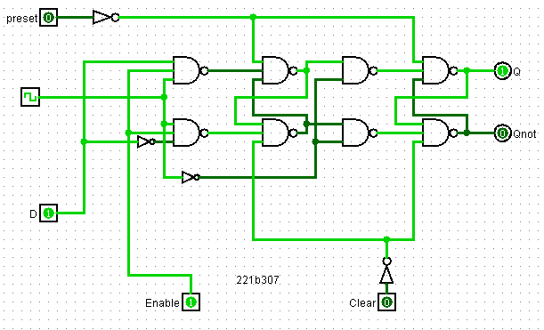
Truth Table or Karnaugh (K) Map
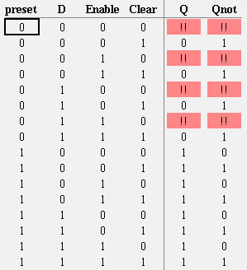

Exercise#2: Design and verify 4-bit SISO shift register (without in-built block) as using D flip-flops as sub-circuit. Also use preset and enable control lines in the design. [Note: Replace clock signal with input pin before using D flip flop as sub-circuit in the design]
Boolean Expressions | Logic Diagram
Bus using decoder and buffer | 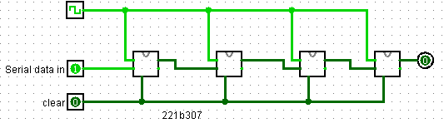
Truth Table or Karnaugh (K) Map

Exercise#3: Design and verify MOD-6 binary counter as shown in Figure-5 using in-built block of D-flip-flop. Display counting using Hex display. Consider QA and Qc as LSB and MSB respectively.

Boolean Expressions | Logic Diagram
F = ~a ~s1 ~s0 + ~a b s1 + a ~b s1 + a s1 ~s0 + a b ~s1 s0 | 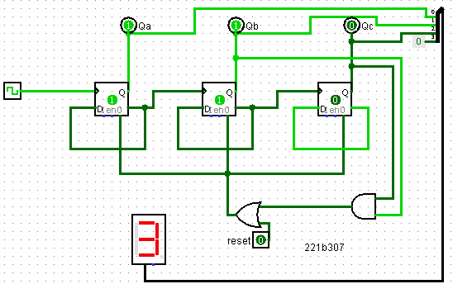
Truth Table or Karnaugh (K) Map

Exercise#4: Design logic circuit to determine whether the input year is leap year or not.
Use four hex displays to show four decimal digits of input year and one hex display to show output
Boolean Expressions | Logic Diagram
 | 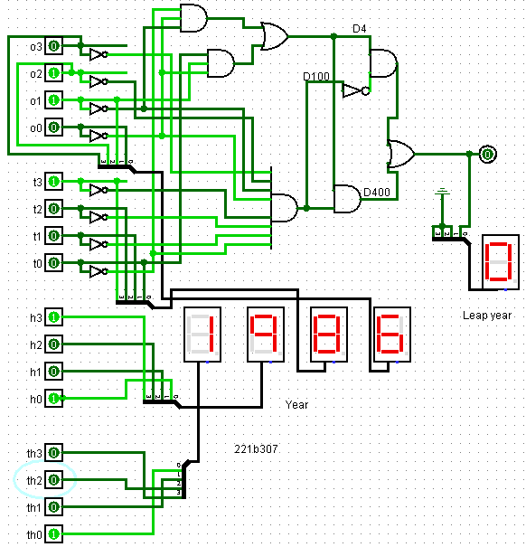
Truth Table or Karnaugh (K) Map

